Dharma Training Programme Retreat Scotland
EARTHING OUR PRACTICE
20-23 October 2022

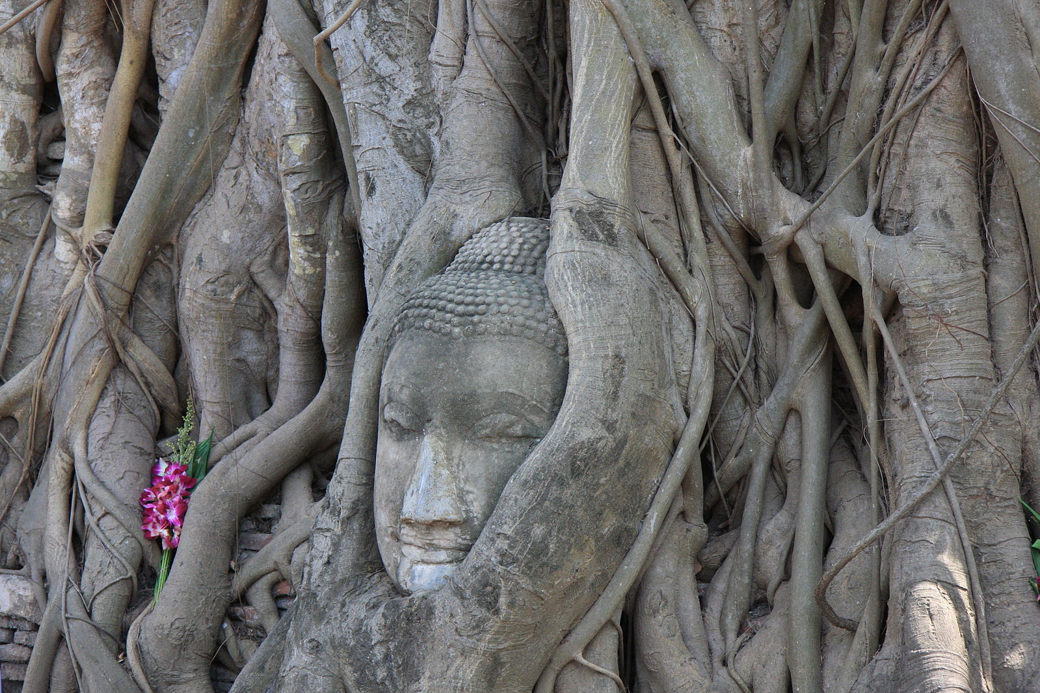

Join us at Kilgraston School for the Scottish Dharma Training Programme retreat for 2022 with Dharma teachers Martin Pitt and Susanne Olbrich.
This retreat will concentrate on deepening our fundamental practice of mindfulness (Sati). We will look deeply at what it means to practise meditation, drawing on the teachings and insights of the Discourse on the Four Establishments of Mindfulness (Satipatthana Sutta) and the Discourse on the Full Awareness of Breathing (Anapanasati Sutta). We will be guided to strengthen our approach to meditation and deepen our mindfulness across many forms of practice, such as sitting, breathing, slow walking meditation as well as chanting and touching the earth. We will also explore what it means to fully integrate mindfulness into our everyday activities such as eating, working and interacting. We will look specifically at how to apply these practices to strengthen our connection with nature and Mother Earth in the context of our current ecological and climate crisis.

Dharma Teachers
Martin first visited Plum Village in 1987 inspired by Thich Nhat Hanh’s teachings on engaged Buddhism. He joined the Order of Interbeing in 1990 and became a Dharma Teacher in the tradition in 1994. Over many years he helped establish the UK Community of Interbeing and has led many meditation retreats and workshops. He lives in Devon with his wife and son and works as a researcher in the Medical School at Exeter University.

Susanne discovered Plum Village and Thay’s teachings in 1996; in 2007 she became a member of the Order of Interbeing with the Dharma name True Ever-present Stability. Susanne lives in the Findhorn community in the North of Scotland where she co-founded the Northern Lights Sangha. As a pianist and music teacher she enjoys encouraging deep listening and creative expression in people of all ages. Her special interest is in offering mindfulness retreats with the themes of creativity and music.

Location:
Kilgraston School, Bridge of Earn, Perthshire, PH2 9BQ

Date and times
Thursday 20th October 2022 – arriving from 4pm for supper at 6pm, to
Sunday 23rd October 2022 – finishing after lunch

Accommodation
All accommodation is in single rooms with washbasins, however the shower and toilet blocks on each corridor are shared. So that everyone can feel safe and comfortable, we ask you to indicate gender identification on the booking form which will allow us to allocate you a room in the appropriate corridor.

If you have any questions, please email Lindsay linds.lumsden@gmail.com or Paloma palomablasco@protonmail.com

SEE NEXT PAGE FOR BOOKING FORM

Dharma Training Retreat Scotland
EARTHING OUR PRACTICE
Kilgraston School, Perthshire
20-23 October 2022

Name
Do you identify as: female male non-binary
Address

Telephone Numbers – Mobile ………………………………………. Home ..
Email address
Emergency contact name………………………………………………… Telephone number…………………………………………….

All food will be vegan. Please indicate if you have other dietary requirements we can help you with
……………………………………………………………………………………………………………………………………………………………………..

Health and wellbeing
To help us make this retreat as inclusive and safe as possible, please tick here if you are currently suffering from any physical or mental difficulties for which you feel you need the additional support of the teachers or group facilitators.
If you tick the box, one of the Dharma Teachers for this retreat will contact you to discuss how we can help. Any information you disclose will only be used to make the retreat accessible and safe for you. It will not be held on any database and will only be shared with the other Dharma Teacher/Dharma Sharing group facilitators or organisers with your express permission.
Please indicate if you would prefer to be contacted by Martin or Susanne

Cost
The cost of the retreat is £220

There will also be the opportunity to offer dana at the end of the retreat to support our teachers, Martin and Susanne. The giving of dana is a practice of generosity that supports the teaching that is freely offered to us and others and is ultimately for the benefit of all beings. Offering dana is not a commercial transaction but a movement of the heart and we suggest that you should feel happy about the donation offered at the time of giving, not too much and not too little, and that you feel happy later looking back on what you gave.

Bursaries
There will be some partial bursaries available. If you would struggle to pay the full cost of the retreat, please contact Lindsay at the email address below.

Booking and payment
Please return your booking form to Lindsay Lumsden at linds.lumsden@gmail.com or Mill House, Glenmillan, Lumphanan AB31 4PS. Payment by BACS is preferred to The Community of Interbeing UK - Sort Code 08-92-99, Account Number 65275935 using the reference KILGRASTON. If you are not able to use BACS, please send a cheque made out to The Community of Interbeing UK with your booking form.

Your booking will be confirmed by email.

