A Scottish Sangha Facilitators’ Retreat
at Kilgraston School, Perth

Thursday 17th February - Sunday 20th February 2022

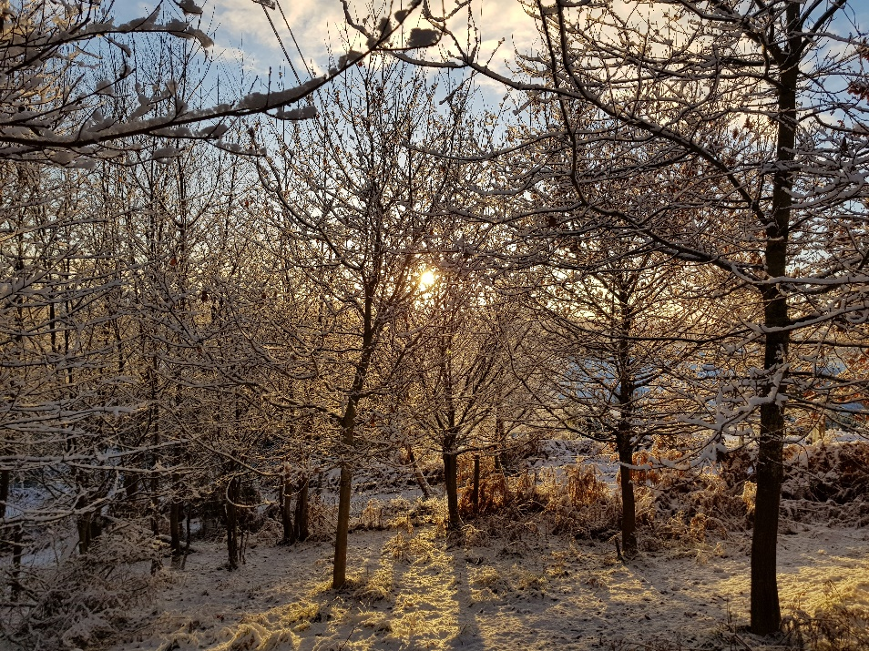
This winter retreat will be facilitated by Murray Corke and Susanne Olbrich, Dharma teachers in the tradition of Zen Master Thich Nhat Hanh.

We warmly invite to the Retreat those currently facilitating sangha sessions or wishing to do so in the future.

We will have the opportunity to practice mindful living together. There will be walking and sitting meditations, shared mindful meals, deep relaxation and Dharma sharing groups.

We invite you to bring any questions you might have about sangha facilitation.

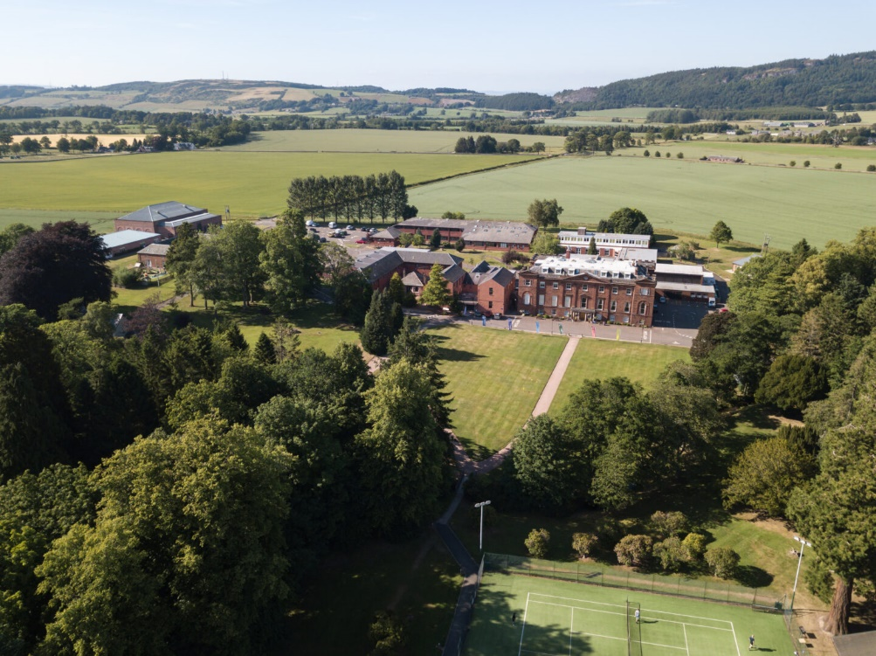
The Retreat will take place at Kilgraston School, a residential girls’ school just outside Perth.

The retreat will run from 1700 hrs Thursday to 1400 hrs Sunday. The programme is designed over three days, so we expect that everyone who comes will come for that time. The cost for the three-day retreat will be £185. A bursary to help with this may be available on application.

If there’s anything about the Retreat that you would like to talk through, do contact
Roland: 07787 50792
:roland.spencerjones@gmail.com

Further instructions – timetable, directions, preparation, etc - will follow nearer the time.

See the attached application form for costs. Note that residential accommodation will be provided in single bedrooms, with toilet and shower facilities at the end of the corridors. It will be possible for local participants to be non-residential at a reduced rate. The School and the Retreat Organisers will ensure that all current Covid government guidelines will be adhered to.

You will be able to express your gratitude to the teachers and support their Dharma teaching by offering Dana at the end of the retreat.

Booking Form Scottish Facilitators’ Retreat

17th–20th February 2022

What is your name:
Which is your local sangha?
Your address?
Telephone Numbers:
e-mail address:
All food will be vegan. Please indicate if you have other dietary requirements we can help you with:
Any disability that we should know about?
Bursary  Please tick this box if you would like to apply for a bursary reduction to the cost of the Retreat. Then just return this form without payment, so that the request can be considered.  (The COI also considers bursaries for anyone attending the Retreat, although this offer is limited to COI members. Further details: https://plumvillage.uk/retreats/bursary-scheme/ ). |  |  |  |  | Tick this bursary box
Method of payment, please tick the relevant box |  |  |  | Bank Transfer (preferred) | Cheque
Payment details:
- Please consider increasing your payment to provide a pool of money for those who will be seeking a bursary.
- Please arrange a BACS transfer for £185 (+optional bursary donation) to Northern Lights Sangha bank account:
- Sort code: 089299 Account No.: 65450857
- Do ensure you use your name as the reference, so that we know who has paid into the account.
- Or, alternatively, send a cheque for £185 (+ optional bursary donation) made payable to Northern Lights Sangha with your completed form, address details below.

Please return this form to Roland
- Either by emailing the completed form to roland.spencerjones@gmail.com
- Or by printing it and posting to: Roland Spencer-Jones, 7 Ruisaurie, Beauly IV4 7AJ
- Thank you….

